Satisfaction as the Conduit: How User Engagement and Experience Create Brand Value in the Metaverse

Abstract
More and more brands are building a presence in immersive digital worlds, and research has not caught up. We still cannot say with confidence what keeps a brand performing well in the metaverse. That gap is where this study starts. We built a configurational model tying user engagement (UE) and user experience (UX) to brand satisfaction (BSAT), and through satisfaction to brand success (BSUC), then tested it on survey data. Two methods do the work: PLS-SEM (partial least squares structural equation modelling) checks that the measures hold up, and fsQCA (fuzzy-set qualitative comparative analysis) works out which combinations of conditions actually yield the outcome. The respondents were 312 active metaverse users in India, a market with real commercial weight that rarely appears in this literature. One result stands out. Engagement alone does not get a brand there, and neither does experience. Success takes a mix, and satisfaction is the element that keeps recurring, working with either experience or engagement. The three-way combination (BSAT × UX × UE) showed the strongest consistency, so there is more than one route to success, which is equifinality in plain terms. For theory, we extend Flow Theory and Self-Determination Theory (SDT) into brand settings that are co-created and technology-mediated. For practice, the findings show strategists how to design virtual experiences that protect identity, sit inside a community and keep people engaged.

Keywords: Metaverse; User engagement ;User experience ;Brand satisfaction ;Brand success; fsQCA

- Introduction:
Think of the metaverse as an immersive digital space running on augmented and virtual reality (AR/VR). People meet each other there, handle virtual objects, and move between digital and physical information as they go (Arya et al., 2024a; Zallio and Clarkson, 2022). For brands, it changes the job. Old-style marketing gives way to digital experiences that can be measured and that deliver real value (Arya et al., 2024a; Hennig-Thurau et al., 2023; Anderson et al., 2024).
An ordinary website or app cannot do what the metaverse does. It layers senses together, dissolves the split between physical and digital, and hooks one person’s engagement into a wider social system, so brands have to keep changing tack to stay in the game (Kopalle et al., 2024; Marvi et al., 2024; Bilgihan et al., 2024; Hwang and Seo, 2025). What is missing is guidance: the research on how to build this into strategy is still thin (Eggenschwiler et al., 2024). Take Nike’s Nikeland on Roblox. Mini-games and rewards pull users in, and the whole thing hints at where marketing is heading (Kumar, 2024; Kozinets et al., 2023).
Four things set metaverse branding apart from a website or an app, and together they are why we reach for a configurational approach. The spaces persist and are shared in three dimensions. People show up as avatars, so who they are and how they act get tangled up with what they consume. Everything happens live, which puts users in the same moment as other people and as brands. And a lot of the value gets made together rather than handed over. Since outcomes come from how these pieces line up, not from any single one, we ask a configurational question: which mixes of engagement, experience and satisfaction produce brand success?
None of this works without emotion. Attachment tracks with stronger brand relationships (Bilgihan et al., 2024; Arya et al., 2022), and interaction that feels immersive and personal builds satisfaction, trust and a sense of identifying with the brand (Shamim et al., 2025; Vo et al., 2025).
Distance stops mattering, too. A brand can reach people anywhere, and personalisation sharpens how they see it and how satisfied they feel (Dwivedi et al., 2023; Chandra et al., 2022). So the central question follows: how do immersive, avatar-led interactions shape the mixes of engagement, experience and satisfaction that end in brand success? Two smaller questions sit underneath. Which combinations are enough for high brand success? And where does brand satisfaction fit in, tying engagement and experience to that success?
We add three things. The first is not another reminder that engagement, experience and satisfaction matter; it is an account of how immersive, avatar-based settings change the way they fit together, with the claim that equifinality several routes that each work is especially strong here. The second pairs Flow Theory with SDT to explain why immersive interaction keeps people engaged and moves satisfaction. The third uses fsQCA to name the exact combinations of engagement, experience and satisfaction that go with high brand success, which is something managers can act on.
So the study stretches Flow Theory and SDT to fit immersive digital ecosystems (Fan et al., 2022).
Put simply: engagement (UE) and experience (UX) come first, satisfaction (BSAT) follows, and satisfaction is what connects to brand success (BSUC). We study how they combine, not each one by itself.

2. Literature Review:
2.1. Immersive Environment
Three things make a metaverse experience better: how immersive it is, how social it is, and how true to life it feels (Arya et al., 2024a). Immersiveness is the sense of being absorbed, mentally and through the senses. People often call it “presence.” It pulls emotion in, and that in turn lifts satisfaction and trust in the brand (Shamim et al., 2025; Daassi et al., 2021; Bilgihan et al., 2024).
Sociability is about how good the social side is. It makes room for working together, for building a community, for forming bonds, and a strong sense of other people being there makes the whole thing more fun and gets users recommending it (Hennig-Thurau et al., 2023; Osborne et al., 2024). Then there is ecological faithfulness, how real the virtual world feels, which earns trust from consumers who care about the environment (Dwivedi et al., 2023).
Pull immersive storytelling, gamification and virtual launches together and you have one of the clearer paths to growth (Bilgihan et al., 2024; Blazquez, 2024; Lee and Shen, 2024). Done well, these experiences build loyalty (Rather et al., 2022). Done badly, they frustrate people, overload them or tip into escapism, which is exactly why design has to stay user-centred and psychologically safe (Lavoie et al., 2021; Duong et al., 2025).

2.2 Conceptualization of User Engagement in The Metaverse
Nobody agrees on one definition. Still, most describe the metaverse as a shared, three-dimensional virtual world built on AR/VR, where people slip between physical and virtual life to work, meet and socialise (Buhalis et al., 2023; Koohang et al., 2023; Kozinets et al., 2023). Figure 1 maps how the two worlds join up behind brand success.
O’Brien and Toms (2010) took early engagement theory further and validated a multifaceted engagement scale. The Mobile User Engagement model reads engagement through motivation, perceived value and satisfaction (Soltani et al., 2024; İlkan et al., 2023).
Others went their own way: holistic Quality of Experience models (Lycett and Radwan, 2019), multi-instrumental methods (Kyriakou et al., 2024) and work reaching into e-government (Li and Shang, 2023; Zhang et al., 2022). Shin (2019) tied immersion in AR games to what goes on cognitively and motivationally.

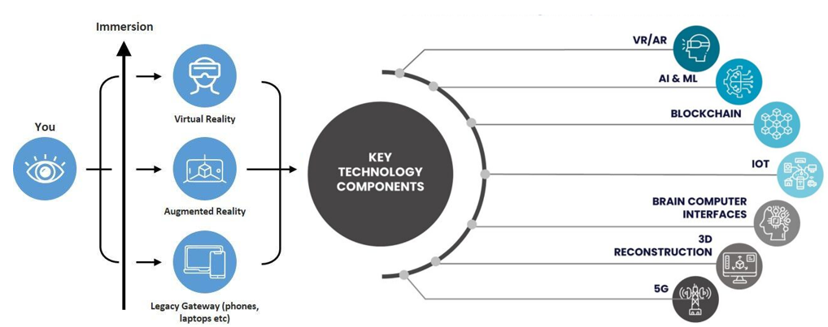
Figure 1. Depiction of Real and Virtual World Integration in the Metaverse. Source: Authors

2.3 Impact of User Behaviours on Brand Engagement in Virtual Environments
What users do buy NFTs, talk to each other, turn up to virtual events, make content is the heart of brand engagement in these worlds. Those actions colour how a brand is seen, forge emotional bonds and keep loyalty going (Shamim et al., 2025; Bilgihan et al., 2024; Lee and Shen, 2024).
Branded NFTs give people a way to say who they are, to signal that they belong to a small group, to build an identity; a one-of-a-kind avatar, a wearable, a collectible, and the attachment runs deeper (Xie and Muralidharan, 2023; Simonetti et al., 2025). Add scarcity and the sense that the thing holds value, and attitudes climb higher, with social comparison pushing the effect along (Wang et al., 2024; Chang et al., 2024; Xie et al., 2024).
Talking to other people keeps engagement alive. Brand communities grow trust, get members sharing what they know and nudge purchase intention upward, while interacting through avatars adds belonging and loyalty (Agnihotri et al., 2024; Kumar and Shankar, 2024; Payal et al., 2024).
Virtual events and gamified rewards earn trust, satisfaction and loyalty, and Gen Z responds to them most of all (Habachi et al., 2024). Let users make some of the content and they feel a stake in it, which turns into advocacy (Bilgihan et al., 2024; Xu et al., 2024).

2.4 Impact of user engagement and experience on brand success in virtual environments
Few things drive brand success like engagement and experience. Wiertz and De Ruyter (2007) showed that when people contribute to a firm’s online community the brand does better, and sharing knowledge is the engine underneath.
Engagement does not rise on its own; brands have to prompt the interaction (Huang and Benyoucef, 2013). Culture plays a part as well: holistic thinkers warm to brand extensions more readily in virtual settings (Su et al., 2021).
Then there is social media, which sits right at the centre. When people identify more strongly and the content is more interactive, they engage with it more (Hsieh and Tsao, 2019).
Brodie et al. (2011) read engagement as taking an active part in brand experiences, and in virtual communities the urge to buy often serves social and identity needs, which turns engagement into a road toward loyalty.

- Theoretical Foundation
3.1 Flow theory
For studying engagement in the metaverse, Flow Theory (Csikszentmihalyi, 1990) earns its keep. Flow is that state of deep, focused immersion, driven from the inside and genuinely enjoyable, and it matters most where engagement decides whether a brand succeeds. Newer work has carried it into VR and AR: in game-based metaverses, the more people enjoy themselves the more flow they feel, and satisfaction and repeat use follow (Hyeon and Lee, 2025).
Flow keeps turning up in studies of virtual brand experiences. In live streaming, authenticity, interactivity and entertainment all raise it, and interactivity does the most (Wu et al., 2024). Technology drives it in emerging-market metaverse use (Liang et al., 2024). It even bends time, making it feel quicker in VR (Rutrecht et al., 2021), and it shapes how people join in and share (Lo and Lai, 2023). Knowing this, we wrote flow into the survey clear goals, quick feedback, a match between challenge and skill and asked users how much of it they felt while inside the metaverse.

  - Self-Determination Theory (SDT)
Self-Determination Theory (SDT) makes a simple claim: people are most motivated and best off when three needs are met, the need to choose for themselves (autonomy), the need to feel capable (competence) and the need to feel connected (relatedness) (Deci and Ryan, 2000). Online, that is why the pull to explore, get good at something and connect drives people in deeper.
The two theories work as a pair. Flow catches the immersion of the moment, when challenge and skill are level and goals and feedback fall into place (Csikszentmihalyi, 1990). SDT says why anyone gets there and stays: autonomy lets them explore, competence pushes them to master, relatedness keeps the social thread alive through their avatars. Between them, they explain the immersion and the met needs that sit under engagement, satisfaction and loyalty.
3.3 Constructs and Hypotheses
Four constructs carry the study. User engagement (UE) is how far a user is involved with a brand cognitively, emotionally and behaviourally while inside the metaverse. User experience (UX) is how good that interaction feels, taking in immersion, usability, enjoyment and presence. Brand satisfaction (BSAT) is the overall verdict a user reaches about the brand after those encounters. Brand success (BSUC) is the payoff: continuance intention, purchase intention, advocacy, word of mouth. The SDT needs and the Flow dimensions run underneath as psychological mechanisms; we did not measure them as constructs of their own.
Read together, Flow Theory and SDT say that immersive interaction which meets people’s needs lifts engagement and experience, and that shapes satisfaction and, past it, brand outcomes. So we expect more engagement to come with more brand success (H1), and better experience to come with more brand success (H2). Satisfaction gathers up a user’s evaluations over time, so we expect it to mediate the paths from engagement and experience to success (H3). And, in the configurational spirit, high brand success may follow from several sufficient mixes rather than any one condition that has to be present (P1).

4. Methodology
4.1 Fuzzy set Qualitative Comparative Analysis and its Application to the study
Fuzzy-set Qualitative Comparative Analysis (fsQCA) gives branding research a mixed-method way into tangled causal configurations (Jia et al., 2022). It falls between exploring and testing: it shows how conditions, present or not, combine to bring about an outcome, and it puts equifinality on the table (Schneider and Wagemann, 2012). For small samples it is a good fit (Ragin, 2008).
There are six stages to it: pick the cases, name the causal conditions, calibrate the membership scores, build the truth table, run the logical minimisation, then check robustness with consistency and coverage. Figure 2 sets out the sequence. Boolean minimisation boils the data down to the smallest sufficient combinations and surfaces causal complexity that a single-variable look would flatten.
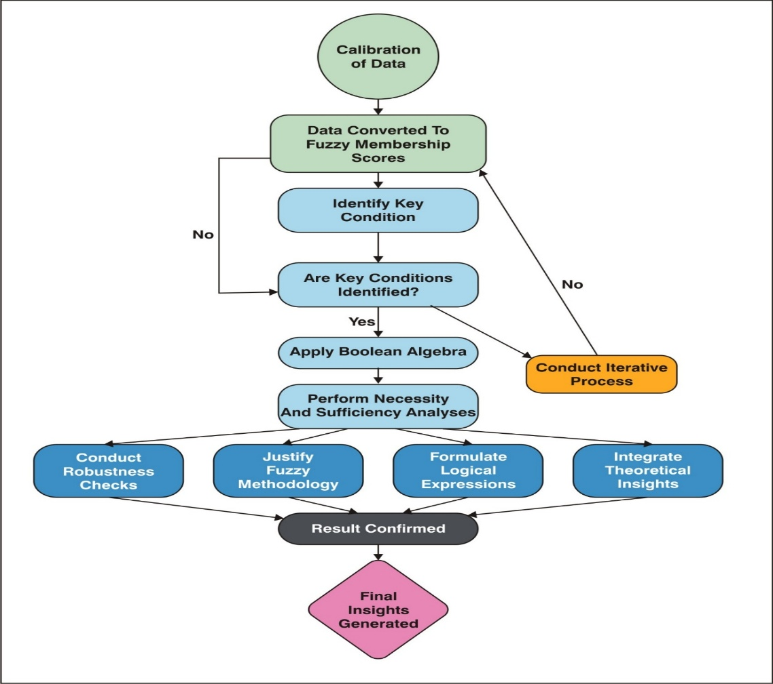
Figure 2. Flowchart illustrating the steps involved in the fuzzy set qualitative comparative analysis (FsQCA) methodology, from data calibration to the generation of final insights.

4.2 Identification and selection of variables
Selecting the variables took three steps. Step one was a literature review, which surfaced the ones that keep proving out satisfaction, how often people interact, perceived brand impact, emotional connection and personalisation as the core (Cadet and Chainay, 2020; Lu and Lau, 2025).
Step two, interviews and focus groups, filled in the detail on involvement, on what makes people satisfied and on how they judge whether a brand has succeeded, and that sharpened the list. Step three was the survey itself, capturing UE, UX, BSAT and BSUC (Table 2). We measured immersiveness with presence scales, sociability with social and co-presence measures, and ecological faithfulness with authenticity measures (Cadet and Chainay, 2020; Poeschl and Doering, 2015; Lu and Lau, 2025).
Only constructs on solid conceptual ground with a reliability record made the cut, and a pilot study tested that they were clear and reliable before we ran the full survey.

4.3 Measures
Every construct sat on a seven-point Likert scale, from 1 (strongly disagree) to 7 (strongly agree). The engagement and experience scales, ten items each, are adapted subsets. Appendix Table 1 lists all the items and where we adapted them from.

4.4 Platforms Studied and Metaverse Activities
We settled on three well-known platforms Roblox, Decentraland and The Sandbox because people actually use them, they do enough, and brands can meet users on them. Roblox is the user-generated, social-gaming one, and it hosts branded builds like Nike’s Nikeland (Bilgihan et al., 2024). Decentraland runs on blockchain, so users buy virtual land, trade NFTs and hold community events on it (Brouard, 2024).
The Sandbox is built for voxel creation and for making money from it, and brands such as Adidas use it (Brandes and Dölp, 2025). Across the three, we watched four kinds of activity: trading digital assets, showing up to virtual events, socialising through avatars, and designing assets or experiences (Lee and Shen, 2024; Hennig-Thurau et al., 2023).

4.5 Data Collection
Sampling was stratified and random. We drew from adults (18+) who were active on at least one platform and had dealt with a brand in the metaverse before, invited 600 of them at random, and stratified by what they mainly did there (gaming, NFT trading, socialising, making content, attending virtual events). 312 came back with complete, consenting answers, a 52% response rate, and the spread was balanced. All of them were measured on the validated UE, UX, BSAT and BSUC scales.
There are good reasons to run this in India, on paper and in the data. It is one of the fastest-growing metaverse markets anywhere (USD 2 billion in 2023, and set to keep growing at a strong CAGR through 2030), and it has a big, digitally raised young population (median age 28), a fast 5G rollout and heavy mobile-first use (Verma, 2024; Statista, 2025; Dwivedi et al., 2023). Indian consumers take to avatar-based self-expression and to owning NFTs, which makes the market especially worth studying, and looking at a non-Western, under-studied setting stretches how far the findings reach (Payal et al., 2024).

5. Data Analysis and Results
5.1. Sample Profile
A descriptive pass in IBM SPSS 25.0 profiled the 312 respondents (Table 1). 46% were men (143) and 54% women (169), spread over age bands from 18 to 45, and the biggest single group, at 24.04%, was 23–28.
On how they used the metaverse: 60.58% were on it several times a week; 45.19% traded NFTs, 52.56% socialised or made content, and 41.35% went to virtual events, which tells you how much of brand engagement rides on these activities.

Table 1: Demographic and Metaverse Engagement Details of Respondents (N = 312)
Participants' Information | No. of Participants | % | Participants' Information | No. of Participants | %
Gender |  |  | Metaverse Engagement Frequency
Male | 143 | 46.00 | Daily | 52 | 16.67
Female | 169 | 54.00 | Several times a week | 98 | 31.41
 |  |  | Weekly | 73 | 23.38
Age (Years) |  |  | Monthly | 54 | 17.31
18–22 | 64 | 20.51 | Rarely | 35 | 11.21
23–28 | 75 | 24.04
29–34 | 60 | 19.23 | NFT Interaction
35–41 | 57 | 18.27 | Yes | 141 | 45.19
42–45 | 56 | 17.95 | No | 171 | 54.81
Marital Status |  |  | Virtual Event Participation
Single | 107 | 34.29 | Yes | 129 | 41.35
Married with children | 84 | 26.93 | No | 183 | 58.65
Married without children | 121 | 38.78 | Social Interaction/Content Creation
 |  |  | Yes | 164 | 52.56
Occupation |  |  | No | 148 | 47.44
Students | 88 | 28.21 | Monthly Family Income
Job | 102 | 32.69 | INR 30,000 or less | 57 | 18.40
Business | 122 | 39.10 | INR 30,001–50,000 | 80 | 25.64
 |  |  | INR 50,001–80,000 | 100 | 32.05
 |  |  | INR 80,001 and above | 75 | 23.91
Source: Authors

5.2. Assessment of Reliability and validity
PLS-SEM came back clean on reliability and consistency. We judged the measurement model on standardized loadings, Cronbach’s α, composite reliability (CR) and average variance extracted (AVE). The loadings sat between 0.699 and 0.741 for Brand Satisfaction, 0.670 and 0.707 for User Engagement, 0.677 and 0.714 for User Experience, and 0.661 and 0.682 for Brand Success, every one clearing the 0.60 floor with significant z-values (p < .001) (Bagozzi and Yi, 1988; Table 2).
Cronbach’s α and CR landed at 0.84 (BSAT), 0.90 (UE), 0.90 (UX) and 0.77 (BSUC), all past the 0.70 mark (Nunnally and Bernstein, 1994; Hair et al., 2019), so the items hang together as measures of their constructs.
For convergent validity, every loading was positive and significant (p < .001), with CR from 0.77 to 0.90 (Table 2). AVE came in at 0.51 (BSAT), 0.48 (UE), 0.48 (UX) and 0.45 (BSUC). Three slipped just under 0.50, but with loadings that significant and CR that solid, convergent validity still stands (Fornell and Larcker, 1981).
We ran Harman’s single-factor test for common method bias (Podsakoff et al., 2003). One unrotated factor accounted for 31.4% of the variance, comfortably under 50%. We had also built in safeguards anonymity, no right or wrong answers, predictor and criterion items kept apart which held the bias down, though self-report data collected at one point in time can never clear it completely.
Discriminant validity came from the Heterotrait–Monotrait (HTMT) ratio (Hair et al., 2019; Henseler et al., 2015). Not one value reached the 0.85 threshold; the highest, for the engagement–experience pair, was 0.814 (Table 2a). Each construct, then, stands on its own empirically. Put that next to the Harman result and neither method bias nor weak discriminant validity puts the conclusions at risk.

Table 2. Reliability Statistics
Factor Loadings
Factor | Indicator | Estimate | Cronbach’s Alpha | AVE | SE | Z | p
Brand Satisfaction | BSAT_1 | 0.705 | 0.841 | 0.514 | 0.0323 | 21.8 | <.001
 | BSAT_2 | 0.741 |  |  | 0.0337 | 22.0 | <.001
 | BSAT_3 | 0.721 |  |  | 0.0328 | 21.9 | <.001
 | BSAT_4 | 0.719 |  |  | 0.0335 | 21.5 | <.001
 | BSAT_5 | 0.699 |  |  | 0.0328 | 21.3 | <.001
User Engagement | UE_1 | 0.684 | 0.903 | 0.481 | 0.0322 | 21.3 | <.001
 | UE_2 | 0.696 |  |  | 0.0325 | 21.4 | <.001
 | UE_3 | 0.706 |  |  | 0.0325 | 21.7 | <.001
 | UE_4 | 0.684 |  |  | 0.0334 | 20.5 | <.001
 | UE_5 | 0.698 |  |  | 0.0327 | 21.3 | <.001
 | UE_6 | 0.705 |  |  | 0.0325 | 21.7 | <.001
 | UE_7 | 0.677 |  |  | 0.0323 | 20.9 | <.001
 | UE_8 | 0.707 |  |  | 0.0326 | 21.7 | <.001
 | UE_9 | 0.670 |  |  | 0.0311 | 21.5 | <.001
 | UE_10 | 0.706 |  |  | 0.0325 | 21.7 | <.001
User Experience | UX_1 | 0.690 | 0.902 | 0.481 | 0.0327 | 21.1 | <.001
 | UX_2 | 0.681 |  |  | 0.0319 | 21.3 | <.001
 | UX_3 | 0.714 |  |  | 0.0325 | 22.0 | <.001
 | UX_4 | 0.694 |  |  | 0.0326 | 21.3 | <.001
 | UX_5 | 0.678 |  |  | 0.0317 | 21.4 | <.001
 | UX_6 | 0.706 |  |  | 0.0328 | 21.5 | <.001
 | UX_7 | 0.687 |  |  | 0.0317 | 21.7 | <.001
 | UX_8 | 0.677 |  |  | 0.0320 | 21.1 | <.001
 | UX_9 | 0.703 |  |  | 0.0319 | 22.0 | <.001
 | UX_10 | 0.702 |  |  | 0.0321 | 21.9 | <.001
Brand Success | BSUC_1 | 0.661 | 0.765 | 0.448 | 0.0308 | 21.5 | <.001
 | BSUC_2 | 0.662 |  | 0.448 | 0.0314 | 21.1 | <.001
 | BSUC_3 | 0.673 |  | 0.448 | 0.0313 | 21.5 | <.001
 | BSUC_4 | 0.682 |  | 0.448 | 0.0317 | 21.5 | <.001

UE: User Engagement, UX: User Experience, BSAT: Brand Satisfaction, BSUC: Brand Success
Source: Authors
Table 2a. Heterotrait–Monotrait (HTMT) Ratio Matrix
Construct | BSAT | BSUC | UX | UE
Brand Satisfaction (BSAT)
Brand Success (BSUC) | 0.743
User Experience (UX) | 0.768 | 0.712
User Engagement (UE) | 0.756 | 0.729 | 0.814

Note: All HTMT values below 0.85 confirm discriminant validity. BSAT = Brand Satisfaction; BSUC = Brand Success; UX = User Experience; UE = User Engagement. Values derived from SmartPLS 4.1 bootstrapping procedure (5,000 subsamples). Source: Authors.
Figure 3 lays out the Pearson correlation matrix from Jamovi, with the item-to-item relationships across BSAT, UE, UX and BSUC shown on a colour gradient that runs from strong positive to strong negative.
All the standardized loadings were positive and significant, and the heatmaps (panels a–d) show positive, significant correlations among items inside each construct, which is what you would expect if each is unidimensional; none got close to the 0.95 line where multicollinearity would worry you.
The square root of AVE (0.72 BSAT, 0.69 UE, 0.69 UX, 0.67 BSUC) sits near the correlations between constructs, a sign of how conceptually close they are, so discriminant validity leans mainly on HTMT (Table 2a), every ratio under 0.85.
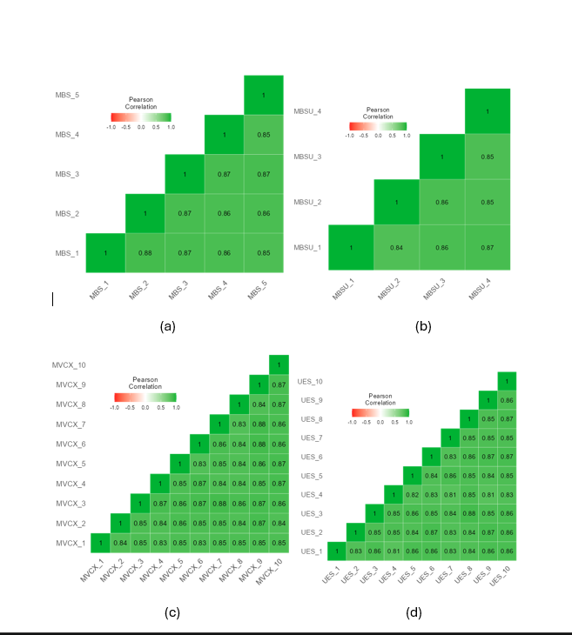
Figure 3. Correlation Heatmap Obtained using Jamovi Software.
Pearson correlation heatmaps for measurement items: (a) Brand Satisfaction (BSAT_1 to BSAT_5), (b) Brand Success (BSUC_1 to BSUC_4), (c) User Experience (UX_1 to UX_10), and (d) User Engagement (UE_1 to UE_10), illustrating positive inter-item correlations within each construct.
Source: Authors.

5.3. Data Analysis using FsQCA
5.3.1. Data Driven Results from FsQCA
To get UE, UX, BSAT and BSUC ready, we calibrated the raw answers (Ragin, 2008) into fuzzy-set membership scores each one saying how far a case belongs to a condition and to the outcome.
Calibration hung on three anchors: the 95th percentile for full membership (0.95), the 50th as the crossover (0.50), the 5th for full non-membership (0.05), with everything kept between 0 and 1 (Ragin, 2008; Douglas et al., 2020). On that common scale we can line up the calibrated UE, UX, BSAT and BSUC values (Table 3).

Table 3. Intermediate Solution
Model: BSUC = f (BSAT, UX, UE) | Raw coverage | Unique coverage | consistency
BSAT x UX | 0.208 | 0.036 | 0.650
BSAT x UE | 0.241 | 0.069 | 0.669
UX x UE | 0.219 | 0.046 | 0.600
User Experience (UX), User Engagement (UE), Brand Satisfaction (BSAT), and Brand Success (BSUC)
Note: solution coverage: 0.323827; solution consistency: 0.756327 Source: Authors

Table 3 shows the intermediate solution modelling BSUC = f(BSAT, UX, UE). Raw coverage runs to roughly 20.84% for BSAT × UX, 24.15% for BSAT × UE and 21.90% for UX × UE, with unique coverage of 3.59%, 6.90% and 4.65% in turn.
Consistency, the sufficiency signal, reads 0.650 for BSAT × UX, 0.669 for BSAT × UE and 0.600 for UX × UE (Table 4). For the intermediate solution as a whole, coverage is 0.324 about 32% of the outcome and consistency is 0.756.
Figure 4 presents the framework for brand success, illustrating the proposed relationships among UX, UE, BSAT and BSUC in the metaverse.
Here UX, UE and BSAT are the antecedent conditions for BSUC. Rather than fitting one directional path, the subset–superset analysis asks which combinations are jointly enough for high brand success, which ties the conceptual model back to what the data actually show.
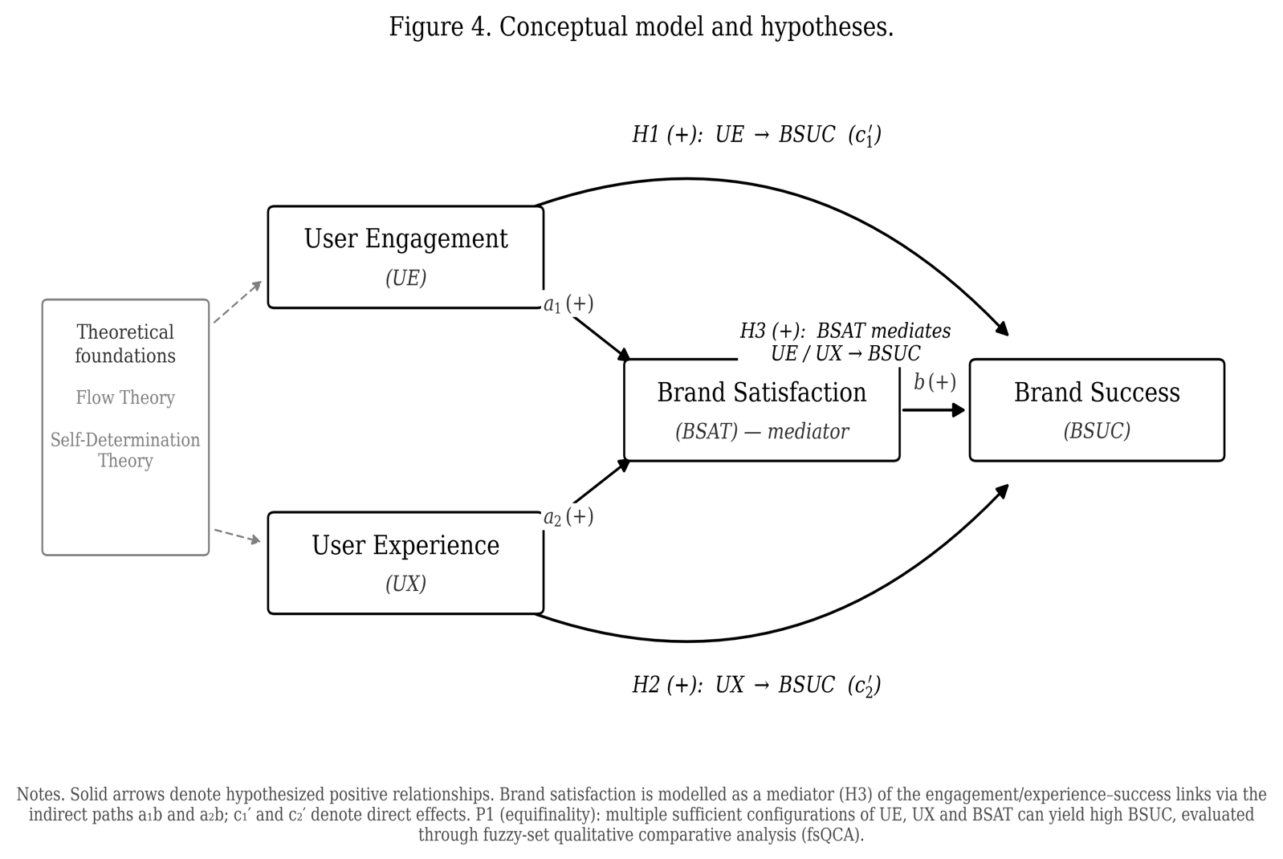
Figure 4. Conceptual model and hypotheses (H1–H3): user engagement (UE) and user experience (UX) as antecedents, brand satisfaction (BSAT) as mediator, and brand success (BSUC) as the outcome, framed by Flow Theory and Self-Determination Theory.
Source: Authors

Table 4. Subset/Superset Analysis
BSUC = f (BSAT, UX, UE) | Consistency | Raw Coverage | Combined
BSAT * UX * UE | 0.713 | 0.172 | 0.305
BSAT * UX | 0.650 | 0.208 | 0.246
UX * UE | 0.600 | 0.219 | 0.181
BSAT * UE | 0.669 | 0.241 | 0.295
UX | 0.362 | 0.349 | 0.084
BSAT | 0.410 | 0.368 | 0.086
UE | 0.373 | 0.349 | 0.084
User Experience (UX), User Engagement (UE), Brand Satisfaction (BSAT), and Brand Success (BSUC)
Source: Authors

Table 5. Configuration Analysis for High Brand Success (BSUC) in the Metaverse
Configuration | 1 | 2 | 3
Causal Conditions
BSAT (Brand Satisfaction) | ● | ●
UX (User Experience) | ● |  | ●
UE (User Engagement) |  | ● | ●
Performance Metrics
Raw Coverage | 0.208 | 0.241 | 0.218
Unique Coverage | 0.036 | 0.069 | 0.047
Consistency | 0.650 | 0.669 | 0.6
Overall Solution | Coverage: 0.324 | Consistency: 0.756
Note: Key: ● = Core condition present (essential for outcome), Blank = "Don't care" (condition irrelevant for configuration), User Experience (UX), User Engagement (UE), Brand Satisfaction (BSAT), and Brand Success (BSUC) (Outcome variable)

Table 6. Configuration Analysis for High Brand Success (BSUC) – Expanded Subset–Superset Configurations in the Metaverse
Configuration Type | Triple Path (BSAT+UX+UE) | Satisfaction + Experience | Experience + Engagement | Satisfaction + Engagement
Configuration | A | B | C | D
BSAT (Brand Satisfaction) | ● | ● | ● | ●
UX (User Experience) | ● | ● |  | ●
UE (User Engagement) | ● | ● | ●
Raw Coverage | 0.172 | 0.208 | 0.219 | 0.241
Consistency | 0.713 | 0.65 | 0.6 | 0.669
Combined Coverage | 0.305 | 0.246 | 0.181 | 0.295
Note: Key: ● = Core condition present (essential for outcome), Blank = "Don't care" (condition irrelevant for configuration), User Experience (UX), User Engagement (UE), Brand Satisfaction (BSAT), and Brand Success (BSUC) (Outcome variable)

Tables 5 and 6 make the point about equifinality: more than one distinct path arrives at the same outcome (Ragin, 2008). Alone, none of BSAT, UX or UE is necessary. It is how they interact that moves brand outcomes in immersive settings.
Table 5 gives three core configurations for high BSUC. In the first (BSAT + UX), the brand succeeds even with engagement low, because a satisfied user who has had a good immersive experience sticks around (Bilgihan et al., 2024). The second (BSAT + UE) puts satisfaction next to active participation, and loyalty and advocacy grow (Hollebeek et al., 2022). The third (UX + UE) shows that even when nobody reports being satisfied, an immersive, interactive setting can still pay off, which is Flow Theory’s point (Csikszentmihalyi, 1990).
Table 6 opens these up through subset–superset analysis. Configuration A, the “Triple Path” (BSAT, UX, UE), has the best combined coverage at 0.305: users who are satisfied, engaged and immersed squeeze the most out of a brand, and that squares with service-dominant logic and value co-creation.
The rest show how flexible this is. B (BSAT + UX) and D (BSAT + UE) say the same thing from two sides, that satisfaction pairs with either experience or engagement, so brands can pick their route. C (UX + UE) is lower on consistency but still backs the case for immersive, participatory experiences even where satisfaction is not stated outright (Shin, 2019).
5.3.2. Necessity Analysis
The necessity check asks whether any single condition has to be there; the bar is a consistency above 0.90 (Schneider and Wagemann, 2012). Nothing cleared it, single-condition consistency came to 0.373 for UE, 0.362 for UX and 0.410 for BSAT. High brand success, then, is a matter of combinations, not one necessary condition, which is why we turn to sufficiency.

5.3.3. Sufficiency Analysis
Sufficiency is about finding the combinations that are jointly enough. We put UE, UX and BSAT into the truth table and set consistency and frequency thresholds (Ragin, 2008; Schneider and Wagemann, 2012). Tables 5 and 6 tell the story: satisfaction is in every high-consistency sufficient path, while engagement and experience pull their weight in combination, not solo.
All three sufficient configurations echo what earlier work found. BSAT × UX scores high on both coverage and consistency: a satisfied user who enjoys a well-made experience stays loyal and talks the brand up. BSAT × UE is nearly as strong, in line with the engagement–loyalty link (Jeong and Kim, 2019) and with social media’s pull on customer equity (Ebrahim, 2020). UX × UE trails a little on consistency, which fits how experience and engagement lean on each other in immersive settings.
Engagement here has many sides trading assets, going to events, socialising, making content and it reflects motives that are psychological, social and experiential, all caught through the UE and UX constructs rather than through anything tied to a specific platform.

5.4 Structural Model and Hypothesis Evaluation
Because fsQCA is about sufficiency, not net linear effects, we test the hypotheses configurationally (Table 7). As the necessity result implied, engagement (single-condition consistency 0.373) and experience (0.362) are not enough on their own; they help only in combination, which is where H1 and H2 hold. Satisfaction shows up in every high-consistency path the triadic BSAT × UX × UE at 0.713, BSAT × UE at 0.669, BSAT × UX at 0.650 and posts the highest single-condition consistency at 0.410, which reads as a central, mediation-like role and supports H3. A formal bootstrap mediation test would round this out.
Table 7. Hypothesis Evaluation Based on fsQCA Sufficiency Analysis. Source: Authors, from configurational results reported in Tables 5 and 6.

Hypothesis | Configurational evidence (fsQCA) | Key values | Outcome
H1: User engagement (UE) → brand success (BSUC) | UE not sufficient alone; sufficient in BSAT×UE and UX×UE | UE alone consistency 0.373; BSAT×UE 0.669; UX×UE 0.600 | Supported within configurations
H2: User experience (UX) → brand success (BSUC) | UX not sufficient alone; sufficient in BSAT×UX and triadic path | UX alone consistency 0.362; BSAT×UX 0.650; triadic 0.713 | Supported within configurations
H3: Brand satisfaction (BSAT) mediates UE/UX → BSUC | BSAT present in all high-consistency sufficient paths; highest single-condition consistency | Triadic 0.713; BSAT×UE 0.669; BSAT×UX 0.650; BSAT alone 0.410 | Supported (configurationally); SEM mediation test recommended
Overall solution | Three sufficient configurations (equifinality) | Solution coverage 0.324; solution consistency 0.756

6. Discussion
The fsQCA results show, fairly cleanly, how mixes of UE, UX and BSAT feed brand success in the metaverse, and they mark the main routes to a good outcome.
BSAT × UX came out strong (consistency 0.650, raw coverage 20.84%). A satisfied user who rates the immersive experience highly turns into a loyal advocate, which lines up with earlier work on satisfaction, experience and emotional connection (Thaichon et al., 2022; Bilgihan et al., 2024). The lesson for brands is to make the immersive experience seamless while staying honest about the ethics, data-privacy risk and overuse among them.
BSAT × UE was also strong (consistency 0.669, coverage 24.15%): pair active participation with real satisfaction and outcomes improve, which echoes the engagement–equity link (Jeong and Kim, 2019). Brands should lean into gamified and co-creation activities that pull people in deeper, and keep satisfaction high while they do it.
UX × UE sat a little lower (consistency 0.600, coverage 21.90%), but the message is clear enough: engagement does its best work alongside a high-quality experience, even when satisfaction is not the dominant piece, which is Flow Theory’s challenge–skill balance at work (Csikszentmihalyi, 1990; Shin, 2019).
Single factors were less consistent than their combinations, which argues for a whole-picture strategy. BSAT × UX × UE hit the top consistency at 0.713, backing Flow Theory’s idea that the best engagement comes when challenge and skill are balanced inside an immersive setting (Csikszentmihalyi, 1990).

7. Implications
7.1 Theoretical Contributions
This study puts SDT and Flow Theory to work together inside immersive, digitally mediated settings, the kind marked by lasting communities, avatar-based identity and interactive interfaces, and it spells out how psychological needs and experiential states together shape engagement, satisfaction and brand outcomes. Earlier applications lived in traditional or gamified settings; metaverse interaction is different, blending intrinsic motivation with experiential absorption in a way that stretches both theories into co-created ground.
Inside SDT, autonomy, competence and relatedness look particular here: autonomy in customisable avatars and owning digital assets, competence in skill-based challenges and the achievement that follows, relatedness in the steady social contact of a branded community (Bilgihan et al., 2024). We offer these as the mechanisms behind engagement and experience, not as effects we measured separately.
We push Flow Theory further by arguing that experiential immersion depends on task challenge meeting user skill, with digital affordances and interaction design doing the tuning (Zhong and Hamouda, 2024); gamified missions and event-based interaction are what let flow happen. And, matching our results, deep immersive engagement can still pay off even when satisfaction is not the leading condition.
Taken as a whole, the study moves marketing and psychological theory along by suggesting that met needs and experiential immersion, together, go with engagement, satisfaction and brand performance. It carries SDT and Flow Theory into co-created digital ground, while keeping what we tested apart from how we interpret it.

7.2. Managerial Implications
User experience turns out to be central to both satisfaction and a good outcome; it keeps appearing in the winning configurations. Building metaverse experiences that are engaging, interactive and personal is therefore how you hold engagement and, over time, how you keep the brand successful.
Brands ought to build immersive experiences that plug into who users are in the virtual world. Personalisation customisable avatars, interactive environments hands users a way to express themselves and deepens presence, which tightens the emotional bond. Line the brand’s virtual presence up with a user’s sense of self and the connection forms; tailor the experience and engagement, loyalty and advocacy all deepen (Thaichon et al., 2022; Xie and Muralidharan, 2023).
Features people talk about a lot NFT interoperability, smart contracts, rarity dynamics might well sharpen exclusivity and trust, but we did not measure them, so they belong in the future-work column, not the findings. What the evidence speaks to is combinations of engagement, experience and satisfaction, not anything specific to blockchain.
The numbers show satisfaction and engagement feeding each other: put participation next to high satisfaction and equity and loyalty both strengthen (Jeong and Kim, 2019). So managers should open up gamified, co-creation and reward opportunities that draw people in, since a sense of ownership is what makes attachment and long-run loyalty stick.
The through-line is user experience: central to satisfaction and central to success. To stay competitive, a brand has to make its immersive experiences feel something, stay consistent, and match users’ values and identities (Jung and Pawlowski, 2014); assets that merely work or merely look good will not carry it anymore. The brands that deliver high-quality interactive experiences are the ones building lasting engagement, loyalty and an edge.

8. Limitations and Future Scope
A few limits are worth naming. First, the sample, 312 active and experienced users, buys us expertise but probably tilts things toward the highly engaged and leaves casual or first-time users under-counted, which caps how far the findings generalise; a broader, more representative frame is needed.
Second, what we chose to include or leave out may have skipped something that matters, and with no control group we cannot claim cause outright. fsQCA is good at untangling complex causation, but its small-N, qualitative bent makes it less robust than the bigger quantitative models and leaves less room to triangulate.
Third, a cross-sectional design cannot show how engagement and experience shift over time; that needs longitudinal work to see whether engagement lasts. The ethical side privacy, addiction, cyberbullying, exploitation is still thin on research, and future studies should build protections for users’ well-being.
Finally, with several big technology firms pulling back from the metaverse, we keep our claim modest. The findings apply most directly to brands on large, metaverse-like platforms game worlds such as Roblox and Fortnite, and social VR and to whoever designs the immersive environments that come next. We read avatar-mediated branding as a moving target, but one whose underlying mechanisms engagement, experience, satisfaction should carry across whatever technology arrives.

Acknowledgement:

The author(s) acknowledge the use of generative AI tools to enhance the linguistic quality and readability of this manuscript. These tools were employed solely to improve spelling, grammar, and overall clarity, based on the original content created by the author(s). The author(s) take full responsibility for the original content, interpretations, and conclusions presented in this work.

Funding: This research received no specific grant from any funding agency in the public, commercial, or not-for-profit sectors.
Conflicts of Interest: The authors declare no conflicts of interest.

Appendix Table 1. Measurement Items

The following items were administered to measure each construct, adapted to the metaverse branding context from the cited sources. All items used seven-point Likert scales anchored from 1 (strongly disagree) to 7 (strongly agree). Item codes correspond to the standardized loadings reported in Table 2.
Construct (source) | Code | Item wording (adapted)
User Engagement (UE) adapted from O’Brien and Toms (2010) | UE_1 | I lost track of myself in the brand’s metaverse experience.
 | UE_2 | The time I spent in the brand’s metaverse space slipped away.
 | UE_3 | I was absorbed in what I was doing in the brand’s metaverse space.
 | UE_4 | I felt involved in the brand’s metaverse activities.
 | UE_5 | The brand’s metaverse experience was fun.
 | UE_6 | I was motivated to keep interacting with the brand in the metaverse.
 | UE_7 | I would recommend the brand’s metaverse experience to others.
 | UE_8 | Interacting with the brand in the metaverse was worthwhile.
 | UE_9 | I felt interested in the brand’s metaverse activities.
 | UE_10 | I would return to the brand’s metaverse space.
User Experience (UX) adapted from O’Brien and Toms (2010); Basu et al. (2024); Cadet and Chainay (2020) | UX_1 | The brand’s metaverse environment was easy to use.
 | UX_2 | It was easy to navigate the brand’s metaverse space.
 | UX_3 | The brand’s metaverse environment was visually appealing.
 | UX_4 | The brand’s metaverse space was aesthetically pleasing.
 | UX_5 | I felt present in the brand’s metaverse environment.
 | UX_6 | The brand’s metaverse environment felt realistic.
 | UX_7 | The sensory quality (visuals and sound) of the experience was high.
 | UX_8 | The experience responded smoothly to my actions.
 | UX_9 | I felt immersed in the brand’s metaverse environment.
 | UX_10 | Overall, the brand’s metaverse experience was of high quality.
Brand Satisfaction (BSAT) adapted from Fornell et al. (1996) | BSAT_1 | Overall, I am satisfied with the brand’s presence in the metaverse.
 | BSAT_2 | The brand’s metaverse experience met my expectations.
 | BSAT_3 | The brand’s metaverse experience came close to my ideal.
 | BSAT_4 | I am pleased with my experience of the brand in the metaverse.
 | BSAT_5 | The brand’s metaverse offering was satisfactory.
Brand Success (BSUC) developed for this study, drawing on Mathwick et al. (2008) | BSUC_1 | This brand stands out from competitors in the metaverse.
 | BSUC_2 | I would choose this brand over others because of its metaverse presence.
 | BSUC_3 | I would speak positively about this brand to others.
 | BSUC_4 | The brand has a competitive advantage in the metaverse.
References
Agnihotri, D., Chaturvedi, P., Swarup, K., Mathur, A., Tripathi, V., and Singh, N. (2024). Does social presence drive customer brand engagement and purchase intention in the fashion retail metaverse? The moderating role of self-efficacy. Internet Research. https://doi.org/10.1108/intr-01-2024-0030
Agnihotri, R. (2020). Social media, customer engagement, and sales organizations: A research agenda. Industrial Marketing Management, 90, 291-299.
Alshater, M. M., Nasrallah, N., Khoury, R., and Joshipura, M. (2024). Deciphering the world of NFTs: a scholarly review of trends, challenges, and opportunities. Electronic Commerce Research, 1-57.
Anderson, K. C., Hansen, H., and Laverie, D. (2024). Technology has Agency too! Disentangling Technology's Causal and Structural Agency in a Service System. Journal of Macromarketing, 44(2), 510-533.
Arya, V., Paul, J., and Sethi, D. (2022). Like it or not! Brand communication on social networking sites triggers consumer‐based brand equity. International Journal of Consumer Studies, 46(4), 1381-1398.
Arya, V., Sambyal, R., Sharma, A., and Dwivedi, Y. K. (2024a). Brands are calling your AVATAR in Metaverse–A study to explore XR‐based gamification marketing activities and consumer‐based brand equity in virtual world. Journal of Consumer Behaviour, 23(2), 556-585.
Arya, V., Sethi, D., and Hollebeek, L. D. (2024b). Using augmented reality to strengthen consumer/brand relationships: the case of luxury brands. Journal of Consumer Behaviour. https://doi.org/10.1002/cb.2419
Basu, B., Kar, A. K., and Sen, S. (2024). Antecedents of user experience in the immersive Metaverse ecosystem: Insights from mining user reviews. Communications of the Association for Information Systems, 55(1), 13.
Bilgihan, A., Leong, A. M. W., Okumus, F., and Bai, J. (2024). Proposing a metaverse engagement model for brand development. Journal of Retailing and Consumer Services, 78, 103781.
Blazquez, M. (2024). The Metaverse and its potential for digital sustainability in fashion. Journal of Global Fashion Marketing, 15(3), 303-319.
Brandes, L., and Dölp, K. (2025). Non-Fungible Tokens (NFTs) as Digital Brand Extensions: Evidence on Financial Performance and Parent-Brand Spillovers. International Journal of Research in Marketing. https://doi.org/10.1016/j.ijresmar.2025.01.001
Brodie, R. J., Hollebeek, L. D., Jurić, B., and Ilić, A. (2011). Customer Engagement: Conceptual Domain, Fundamental Propositions, and Implications for Research. Journal of Service Research, 14(3), 252-271.
Brouard, M. (2024). Setting sail in a tokenized world: an exploration of the Bored Ape Yacht club and the co-created consumer experience. International Journal of Research in Marketing. https://doi.org/10.1016/j.ijresmar.2024.03.002
Buhalis, D., Leung, D., and Lin, M. (2023). Metaverse as a disruptive technology revolutionising tourism management and marketing. Tourism management, 97, 104724.
Cadet, L. B., and Chainay, H. (2020). Memory of virtual experiences: Role of immersion, emotion and sense of presence. International Journal of Human-Computer Studies, 144, 102506.
Chandra, S., Verma, S., Lim, W. M., Kumar, S., and Donthu, N. (2022). Personalization In Personalized Marketing: Trends and Ways Forward. Psychology and Marketing, 39(8), 1529-1562.
Chang, C. W., Lai, C. J., and Yen, C. C. (2024). Examining drivers of NFT purchase intention: The impact of perceived scarcity and risk. Acta Psychologica, 248, 104424.
Corne, A., Massot, V., and Merasli, S. (2023). The determinants of the adoption of blockchain technology in the tourism sector and metaverse perspectives. Information Technology and Tourism, 25(4), 605-633.
Csikszentmihalyi, M., Montijo, M. N., and Mouton, A. R. (2018). Flow theory: Optimizing elite performance in the creative realm. In S. I. Pfeiffer, E. Shaunessy-Dedrick, and M. Foley-Nicpon (Eds.), APA handbook of giftedness and talent (pp. 215–229). American Psychological Association.
Csikszentmihalyi, Mihaly. (1990). Flow: The Psychology of Optimal Experience. Journal of Leisure Research, 24(1), pp. 93–94
Daassi, M., and Debbabi, S. (2021). Intention to reuse AR-based apps: The combined role of the sense of immersion, product presence and perceived realism. Information and Management, 58(4), 103453.
Deci, E. L., and Ryan, R. M. (2000). The “What” and “Why” of Goal Pursuits: Human Needs and the Self-Determination of Behavior. Psychological Inquiry, 11(4), 227–268.
Douglas, E. J., Shepherd, D. A., and Prentice, C. (2020). Using fuzzy-set qualitative comparative analysis for a finer-grained understanding of entrepreneurship. Journal of Business Venturing, 35(1), 105970.
Duong, C. D., Ngo, T. V. N., Khuc, T. A., Tran, N. M., and Nguyen, T. P. T. (2025). Unraveling the dark side of ChatGPT: A moderated mediation model of technology anxiety and technostress. Information Technology and People, 38(4), 2015-2040.
Dwivedi, Y. K., Hughes, L., Wang, Y., Alalwan, A. A., Ahn, S. J., Balakrishnan, J., ... and Wirtz, J. (2023). Metaverse marketing: How the metaverse will shape the future of consumer research and practice. Psychology and Marketing, 40(4), 750-776.
Ebrahim, R. S. (2020). The role of trust in understanding the impact of social media marketing on brand equity and brand loyalty. Journal of Relationship Marketing, 19(4), 287-308.
Eggenschwiler, M., Linzmajer, M., Roggeveen, A. L., and Rudolph, T. (2024). Retailing in the metaverse: A framework of managerial considerations for success. Journal of Retailing and Consumer Services, 79, 103791.
Fan, X., Jiang, X., and Deng, N. (2022). Immersive technology: A meta-analysis of augmented/virtual reality applications and their impact on tourism experience. Tourism Management, 91, 104534.
Fornell, C., and Larcker, D. F. (1981). Evaluating Structural Equation Models with Unobservable Variables and Measurement Error. Journal of Marketing Research, 18(1), 39-50.
Fornell, Claes, Michael D. Johnson, Eugene W. Anderson, Jaesung Cha, and Barbara Everitt Bryant. "The American customer satisfaction index: nature, purpose, and findings." Journal of Marketing 60, no. 4 (1996): 7-18.
Fritze, M. P., Marchand, A., Eisingerich, A. B., and Benkenstein, M. (2020). Access-based services as substitutes for material possessions: the role of psychological ownership. Journal of Service Research, 23(3), 368-385.
Furnari, S., Crilly, D., Misangyi, V. F., Greckhamer, T., Fiss, P. C., and Aguilera, R. V. (2021). Capturing causal complexity: Heuristics for configurational theorizing. Academy of Management Review, 46(4), 778-799.
Habachi, S., Matute, J., and Palau-Saumell, R. (2024). Gamify, engage, build loyalty: exploring the benefits of gameful experience for branded sports apps. Journal of Product and Brand Management, 33(1), 57-75.
Hair Jr., J.F., Black, W.C., Babin, B.J. and Anderson, R.E. (2010) Multivariate Data Analysis. 7th Edition, Prentice Hall, Upper Saddle River, 761.
Hair, J. F., Risher, J. J., Sarstedt, M., and Ringle, C. M. (2019). When to use and how to report the results of PLS-SEM. European business review, 31(1), 2-24.
Hennig-Thurau, T., Aliman, D. N., Herting, A. M., Cziehso, G. P., Linder, M., and Kübler, R. V. (2023). Social interactions in the metaverse: Framework, initial evidence, and research roadmap. Journal of the Academy of Marketing Science, 51(4), 889-913.
Henseler, J., Ringle, C. M., & Sarstedt, M. (2015). A new criterion for assessing discriminant validity in variance-based structural equation modeling. Journal of the academy of marketing science, 43(1), 115-135.
Hsieh, J. K., and Tsao, W. C. (2019). Engaging Consumers with Branded Social Media: The Impact of Social Identification, Personal Identification, And Interactivity. Journal of Business Research, 96, 382-391.
Huang, Z., and Benyoucef, M. (2013). From E-Commerce to Social Commerce: A Close Look at Design Features. Electronic Commerce Research and Applications, 12(4), 246-259.
Hwang, I., and Seo, R. (2025). Organizational support for digital transformation in the metaverse: a contingent pathway from user experience to digitalization resistance. RandD Management, 55(2), 420-437.
Hyeon Jo, Jae Kwang Lee; Key Drivers of User Engagement in Game-Based Metaverses: Enjoyment, Escapism, Reward, and Spontaneity. PRESENCE: Virtual and Augmented Reality 2025; 34 219–241.
İlkan, Ş. P., Öztüren, A., Avcı, T., and Irani, F. (2023). Mobile application features effects on the application's engagement and intention for continuing use in tourism. Asia Pacific Journal of Tourism Research, 28(4), 386-400.
Jeong, E., and Kim, S. (2019). Exploring a theoretical framework for understanding the relationship between customer engagement and brand loyalty in social media marketing. Journal of Business Research, 95, 365-374.
Jia, R., Steelman, Z., and Jia, H. (2022). What makes one intrinsically interested in IT? An exploratory study on influences of autistic tendency and gender in the U.S. and India. MIS Quarterly, 45(3), 1603–1634.
Kenton, W. (2023, January 31). Macromarketing: Meaning Compared to Micromarketing. Investopedia. Accessed on June 2024, available at: https://www.investopedia.com/terms/m/macromarketing.asp
Kline, R. B. (2023). Principles and practice of structural equation modeling (5th ed.). The Guilford Press, A Division of Guilford Publications, Inc., 370 Seventh Avenue, Suite 1200, New York, NY 10001.
Koohang, A., Nord, J. H., Ooi, K. B., Tan, G. W. H., Al-Emran, M., Aw, E. C. X., ... and Wong, L. W. (2023). Shaping the metaverse into reality: a holistic multidisciplinary understanding of opportunities, challenges, and avenues for future investigation. Journal of Computer Information Systems, 63(3), 735-765.
Kopalle, P. K., Gangwar, M., and Uppal, A. (2024). Commentary on “AI is Changing the World: For Better or for Worse?”. Journal of Macromarketing, 44(4), 886-891.
Kozinets, R. V. (2023). Immersive netnography: a novel method for service experience research in virtual reality, augmented reality and metaverse contexts. Journal of Service Management, 34(1), 100-125.
Kumar, A., and Shankar, A. (2024). Investigating the role of metaverse influencers’ attributes for the next generation of services. Journal of Services Marketing, 38(7), 816-838.
Kyriakou, T., de la Campa Crespo, M.Á., Panayiotou, A., Chrysanthou, Y., Charalambous, P. and Aristidou, A. (2024), Virtual Instrument Performances (VIP): A Comprehensive Review. Computer Graphics Forum, 43: e15065. https://doi.org/10.1111/cgf.15065
Lavoie, R., Main, K., King, C., and King, D. (2021). Virtual experience, real consequences: the potential negative emotional consequences of virtual reality gameplay. Virtual Reality, 25(1), 69-81.
Lee, C. T., and Shen, Y. C. (2024). Exploring determinants of non-fungible token creators’ engagement behaviors on metaverse-based NFT platforms: A multi-analytical SEM-IPMA method. Journal of Business Research, 185, 114920.
Li, Y., and Shang, H. (2023). How does e-government use affect citizens’ trust in government? Empirical evidence from China. Information and Management, 60(7), 103844.
Liang, Y., Zhang, X., Wang, H., and Liu, M. (2024). Users' Willingness To Adopt Metaverse Drawing on Flow Theory: An Empirical Study Using PLS-SEM and FsQCA. Heliyon, 10(13).
Lo, SY., Lai, CY. Investigating How Immersive Virtual Reality And Active Navigation Mediate The Experience of Virtual Concerts. Sci Rep 13, 8507 (2023).
Lu, Y., and Lau, S. K. (2025). Examining the ecological validity of VR experiments in soundscape and landscape research. Computers in Human Behavior, 162, 108462.
Lycett, M., and Radwan, O. (2019). Developing a quality of experience (QoE) model for web applications. Information Systems Journal, 29(1), 175-199.
Marvi, R., Zha, D., and Foroudi, P. (2024). Elevating B2B branding in a global context: integrating existing literature and proposing a forward-thinking conceptual framework. Industrial Marketing Management, 120, 247-272.
Mathwick, C., Wiertz, C., and De Ruyter, K. (2008). Social capital production in a virtual P3 community. Journal of consumer research, 34(6), 832-849.
Mohammed, S. Y., Aljanabi, M., and Gadekallu, T. R. (2024). Navigating the nexus: a systematic review of the symbiotic relationship between the metaverse and gaming. International Journal of Cognitive Computing in Engineering. https://doi.org/10.1016/j.ijcce.2024.02.001
Nikou, S., Mezei, J., Liguori, E. W., and El Tarabishy, A. (2024). FsQCA in entrepreneurship research: Opportunities and best practices. Journal of Small Business Management, 62(3), 1531-1548.
Nunnally J. C., Bernstein I. H. (1994). Psychometric theory (3rd ed.). New York, NY: McGraw-Hill.
O'Brien, H. L., and Toms, E. G. (2010). The development and evaluation of a survey to measure user engagement. Journal of the American Society for Information Science and Technology, 61(1), 50-69.
Oliveira, W., and Hamari, J. (2025). Flow Experience in Gameful Approaches: A Systematic Literature Review, Scientometric Analysis, and Research Agenda. International Journal of Human–Computer Interaction, 1-27.
Osborne, A. (2024). Design of Social Affordances for Meetings in Social Virtual Reality. UC Santa Cruz. Accessed on December 2024, available at: https://escholarship.org/uc/item/8h51c6s0
Park, Y., Fiss, P. C., and El Sawy, O. A. (2020). Theorizing the Multiplicity of Digital Phenomena: The Ecology of Configurations, Causal Recipes, and Guidelines for Applying QCA. Mis Quarterly, 44(4).
Payal, R., Sharma, N., and Dwivedi, Y. K. (2024). Unlocking the impact of brand engagement in the metaverse on Real-World purchase intentions: Analyzing Pre-Adoption behavior in a futuristic technology platform. Electronic Commerce Research and Applications, 65, 101381.
Podsakoff, P. M., MacKenzie, S. B., Lee, J. Y., & Podsakoff, N. P. (2003). Common method biases in behavioral research: a critical review of the literature and recommended remedies. Journal of applied psychology, 88(5), 879.
Poeschl, S., and Doering, N. (2015). Measuring co-presence and social presence in virtual environments–psychometric construction of a german scale for a fear of public speaking scenario. Annual Review of Cybertherapy and Telemedicine 2015, 58-63.
Ragin, C. C. (2008). Redesigning social inquiry: Fuzzy sets and beyond. University of Chicago Press, Chicago, IL, United States.
Rahman, S. M., et al. (2025). Metaverse platform attributes and customer experience measurement. Journal of Retailing and Consumer Services, 83, 104159.
Rather, R. A., Hollebeek, L. D., Vo‐Thanh, T., Ramkissoon, H., Leppiman, A., and Smith, D. (2022). Shaping Customer Brand Loyalty During the Pandemic: The Role of Brand Credibility, Value Congruence, Experience, Identification, And Engagement. Journal of Consumer Behaviour, 21(5), 1175-1189.
Ribeiro, A., Vieira, V., Alves, L., and Maciel, C. (2024). Vishnu: An approach to support the personalization of self-expressive avatars using context-awareness. International Journal of Human-Computer Studies, 185, 103243.
Rutrecht, H., Wittmann, M., Khoshnoud, S., and Igarzábal, F. A. (2021). Time Speeds Up During Flow States: A Study in Virtual Reality with the Video Game Thumper. Timing and Time Perception, 9(4), 353-376.
Ryan, R. M., and Deci, E. L. (2000). Self-determination theory and the facilitation of intrinsic motivation, social development, and well-being. American Psychologist, 55 (1), 68–78.
Ryan, R. M., and Deci, E. L. (2017). Self-determination theory: Basic psychological needs in motivation, development, and wellness. Guilford Publishing.
Ryan, R. M., and Deci, E. L. (2024). Self-determination theory. In Encyclopedia of quality of life and well-being research (pp. 6229–6235). Cham: Springer International Publishing.
Scheider, S., Lauf, F., Möller, F., and Otto, B. (2023). A reference system architecture with data sovereignty for human-centric data ecosystems. Business and Information Systems Engineering, 65(5), 577-595.
Schneider, C. Q., and Wagemann, C. (2012). Set-theoretic methods for the social sciences: A guide to qualitative comparative analysis. Cambridge University Press, Cambridge, United Kingdom.
Shamim, N., Gupta, S., and Shin, M. M. (2025). Evaluating user engagement via metaverse environment through immersive experience for travel and tourism websites. International Journal of Contemporary Hospitality Management, 37(4), 1132-1174.
Shin, D. (2019). How does immersion work in augmented reality games? A user-centric view of immersion and engagement. Information, Communication and Society, 22(9), 1212-1229.
Simonetti, A., Bigne, E., and Navas, L. F. R. (2025). Consumer brand choice in the metaverse: Exploring personal and social factors. Technological Forecasting and Social Change, 213, 124033.
Soltani Nejad, N., Rastegar, R., and Jahanshahi, M. (2024). Tourist engagement with mobile apps of E-leisure: a combined model of self-determination theory and technology acceptance model. Tourism Recreation Research, 49(4), 714-725.
Statista. (2025). Metaverse India: Market forecast. Statista Market Insights. Retrieved March 21, 2026, from https://www.statista.com/outlook/amo/metaverse/india
Su, L., Monga, A. S. B., and Jiang, Y. (2021). How life-role transitions shape consumer responses to brand extensions. Journal of Marketing Research, 58(3), 579-594.
Takano, M., and Taka, F. (2022). Fancy avatar identification and behaviors in the virtual world: Preceding avatar customization and succeeding communication. Computers in Human Behavior Reports, 6, 100176.
Thaichon, P., Phau, I., and Weaven, S. (2022). Moving from multi-channel to Omni-channel retailing: Special issue introduction. Journal of Retailing and Consumer Services, 65, 102311.
Thorndike, R. M. (1995). Book Review : Psychometric Theory (3rd ed.) by Jum Nunnally and Ira Bernstein New York: McGraw-Hill, 1994, xxiv + 752 pp. Applied Psychological Measurement, 19(3), 303-305.
Verma, S. (2024). India metaverse market outlook to 2030 (Report No. KROD1819). Ken Research Private Limited. Retrieved March 21, 2026, from https://www.kenresearch.com/industry-reports/india-metaverse-market
Vo, T. H., Wei‐Han Tan, G., Pham, N. T., Truong, T. H. D., and Ooi, K. B. (2025). Promoting customer engagement and brand loyalty on social media: The role of virtual influencers. International Journal of Consumer Studies, 49(2), e70028.
Wang, X., Sung, B., and Phau, I. (2024). How rarity and exclusivity influence types of perceived value for luxury. Journal of Brand Management, 31(6), 576-592.
Wiertz, C., and De Ruyter, K. (2007). Beyond The Call of Duty: Why Customers Contribute to Firm-Hosted Commercial Online Communities. Organization Studies, 28(3), 347-376.
Wu, Y.-Y., Batool, H., and Yang, Y.-J. (2024). Relationship between the Characteristics of e-Commerce Live Streaming and Purchase Intentions: Moderating Effect of Hedonistic Shopping Value. Emerging Science Journal, 8(3), 1097–1117.
Xie, Q., Muralidharan, S., and Edwards, S. M. (2024). Who will buy the idea of non-fungible token (NFT) marketing? Understanding consumers’ psychological tendencies and value perceptions of branded NFTs. International Journal of Advertising, 43(6), 987-1015.
Xie, Q., Muralidharan, S., Edwards, S. M., and La Ferle, C. (2023). Unlocking the power of non-fungible token (NFT) marketing: How NFT perceptions foster brand loyalty and purchase intention among millennials and Gen-Z. Journal of Interactive Advertising, 23(4), 356-373.
Xu, S., Bauman, M. J., Ponting, S. S. A., Slevitch, L., Webster, C., and Kirillova, K. (2024). Neolocalism of craft brewery experience: Scale development and validation study. International Journal of Hospitality Management, 120, 103787.
Zallio, M., and Clarkson, P. J. (2022). Designing the metaverse: A study on inclusion, diversity, equity, accessibility and safety for digital immersive environments. Telematics and Informatics, 75, 101909.
Zhang, B., Peng, G., Liu, C., Zhang, Z. J., and Jasimuddin, S. M. (2022). Adaptation behaviour in using one-stop smart governance apps: an exploratory study between digital immigrants and digital natives. Electronic Markets, 32(4), 1971-1991.
Zhang, L., Anjum, M. A., and Wang, Y. (2024). The impact of trust-building mechanisms on purchase intention towards metaverse shopping: the moderating role of age. International Journal of Human–Computer Interaction, 40(12), 3185-3203.
Zhong, Z., and Hamouda, M. (2024). The impact of immersive and flow experiences on consumer participation in hyper‐connected shopping platforms: A metaverse perspective. Journal of Consumer Behaviour, 23(6), 2826-2845.

